Results :

|  |  |  |  |  |
| --- | --- | --- | --- | --- |
| Strand | Gene | Chromosome | Position | Mutation type |
| Gar12 | Gai | I | 5149496 | 52 bp Frameshift  Deletion (DELLA) |
| Gar13 | Gai | I | 5149624 | 1bp (G) Frameshift deletion |

Est-ce qu’on doit mettre les fréquences des variants trouvés, pour mieux montrer la qualité ?

Ce qui est en jaune, je suis pas sûr comment on doit écrire.

Les images à la fin, c’est pour que vous visualisiez mieux.

Dans le tableau, dois-je mettre plus d’info ou sous un autre format ?

Je vais essayer de mettre moi même par Latex

Gar12

The revertant phenotype migth be given by the deletion of the DELLA region, in the GAI gene. In this variant the deletion is shifting the reading frame, because it is shifted one basepair to the left, starting at position 5149496 instead of 5149495, and it is also 52 bp, namely, 1bp bigger than the original gain of function deletion. This deletion is most likely changing all amino acides, and thus rendering the protein unfunctional, losing its suppression effect and letting the plant grow.

There are a few others mutations, but they do not seem to have as big of an effect as this one.

Gar13

In this strand, the deletion at the DELLA region is the same as the one already found in previous studies, still 51bp and starting at position 5149495. There is though, a second mutation further down in the GAI gene, and it is a deletion of a Guanine at position 5149624. This deletion is clearly a frameshift mutation, shifting the aminoacids down the stream and making the protein lose its suppression function.

Other mutations were found but there were not very relevant for this analysis.

Gar 12 GAI DELLA deletion

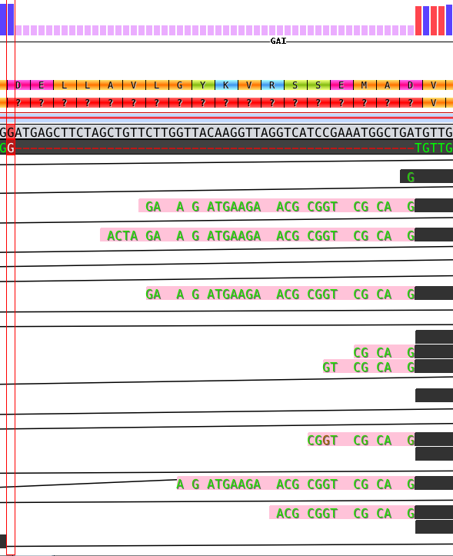

Gar13 G deletion

